

Department of Artificial Intelligence and Data Science

DATA-VIZ HACK-A-BIT
(2025-2026)

Course code and Name:
24ADI204-Data Science and Visualization
Academic Year: 2025-2026 Year/Semester: II/IV

WEEK 4 – Exploratory Data Analysis (EDA)
(Visual Storytelling, Distributions, Correlations, and Temporal Analysis)
DATE:10.02.2026- 16.02.2026
Objective:
The objective of Week 4 is to uncover underlying patterns, correlations, and anomalies in the cleaned flight dataset using visual storytelling. This involves conducting univariate, bivariate, categorical, and advanced temporal analyses to understand the root causes and behaviours of flight delays.
Project Title:
Flight Delay Analysis and Insights
Reason for this week:
Having secured a mathematically clean and robust dataset in Week 3, we must now translate raw numbers into actionable business insights. EDA allows us to visually understand the shape of our data (e.g., heavy-tailed distributions), prove or disprove hypotheses (e.g., does a late departure guarantee a late arrival?), and identify which variables (like airlines, weather, or seasons) carry the highest risk of disruption.

Week No 4 – Activity/Milestone
- Post-Cleaning Data Audit: Verified the integrity of the flight_delay_cleaned.csv dataset, confirming that extreme outliers remained safely capped at 1440 minutes and cancelled flights were successfully excluded.
- Univariate Analysis: Generated zoomed-in histograms (0-300 mins) to accurately visualize the Power Law distribution of both Arrival and Departure delays.
- Bivariate Density Mapping: Engineered high-transparency scatter plots (alpha=0.05) to handle over 1.7 million rows without overplotting, revealing the direct 1:1 relationship between departure and arrival delays.
- Categorical Performance: Analysed the operational variance of the Top 10 highest-volume airlines using boxplots.
- Feature Engineering & Seasonal Risk: Created a new categorical feature (SEASON) and developed an advanced probability bar plot to calculate the exact risk factor (>15 min delay) across Winter, Summer, and Monsoon/Fall.
- Correlation Analysis: Built a targeted correlation heatmap of delay causes to identify mathematical relationships between operational, weather, and airspace delays.

Interactive Python GitHub/Kaggle Link
- GitHub Repository:
https://github.com/DATA-VIZ-HACK-A-BIT/dsv-project-team_2
- Dataset source (Kaggle link):
https://www.kaggle.com/datasets/karthick564/flight-delay-analysis
Cleaned Dataset source (Kaggle link):
Flight_delay_analaysis_cleaned

Code, Screenshots, and Insights
1. Data Verification & Univariate Analysis (Distributions)
Goal: To understand the frequency and spread of flight delays.
Insight: Because flight delays follow a heavy-tailed distribution, we zoomed in on the 0-300 minute range. The data shows a massive concentration at zero, quickly trailing off, confirming that extreme delays are rare but highly impactful.
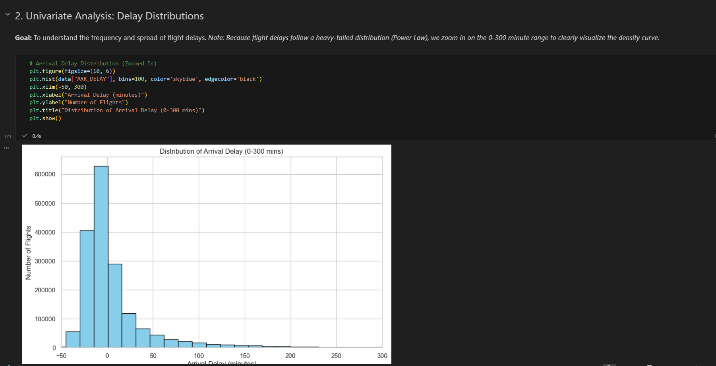

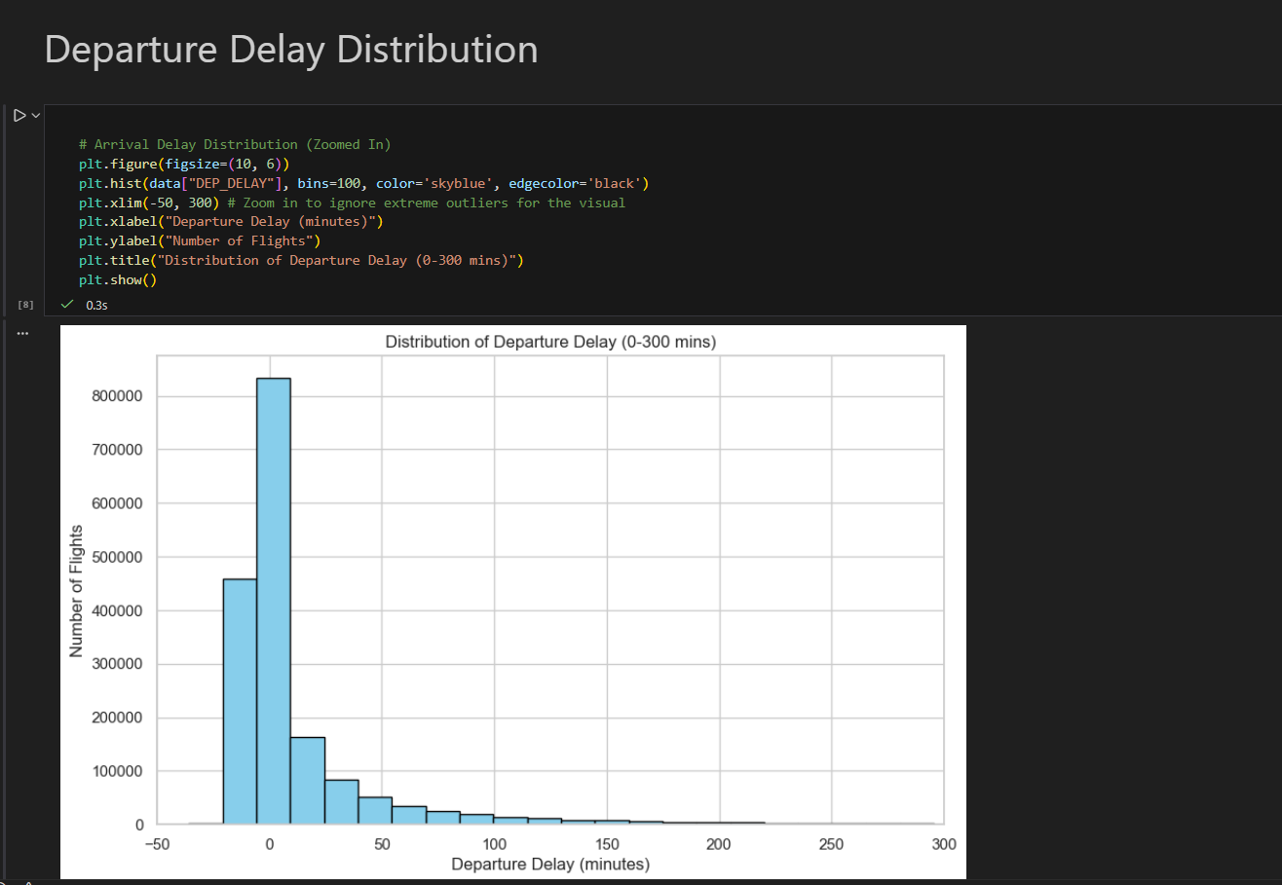
2. Bivariate Analysis (Departure vs. Arrival Delay)
Goal: To visualize how heavily Arrival Delays depend on Departure Delays.
Insight: By applying a heavy transparency layer to handle our massive dataset, we created a density map. Flights plotting below our 1:1 reference line indicate instances where pilots successfully "made up time" in the air despite a late departure.
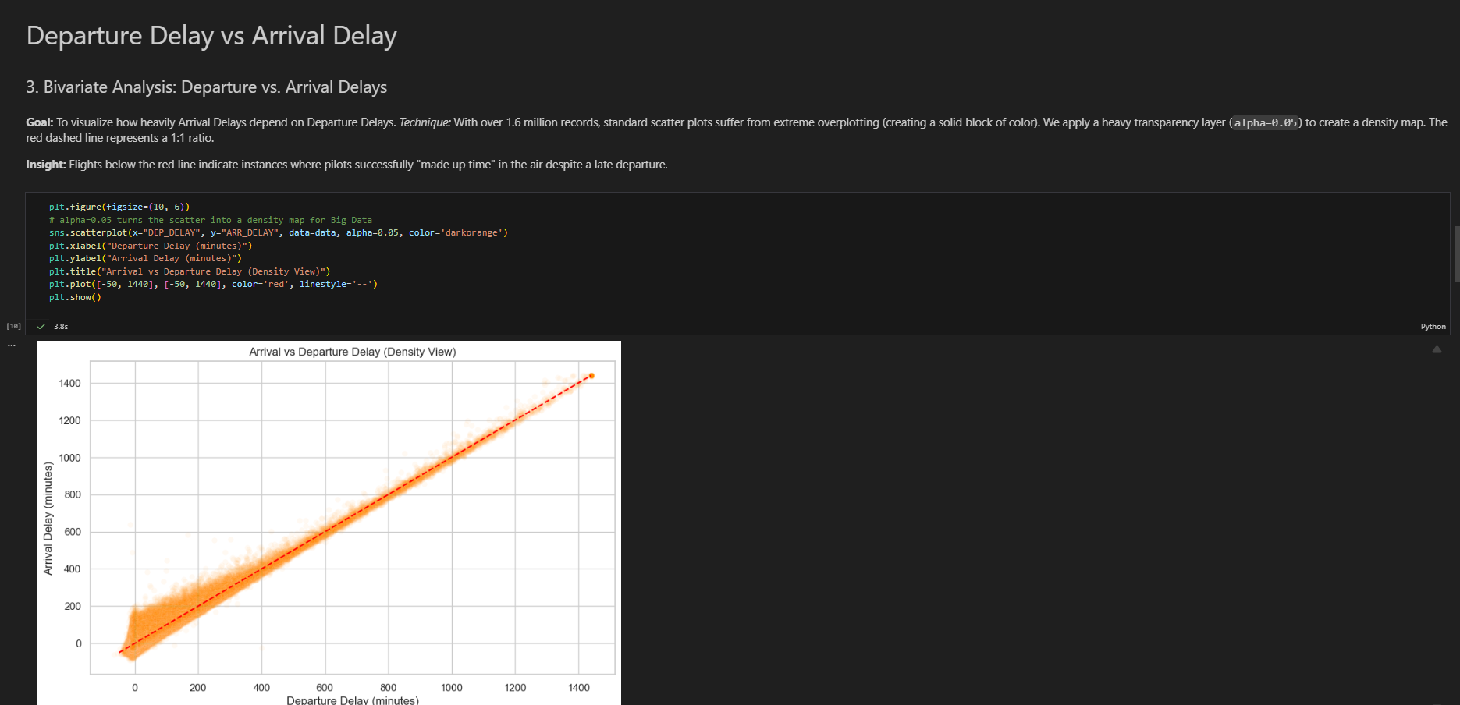

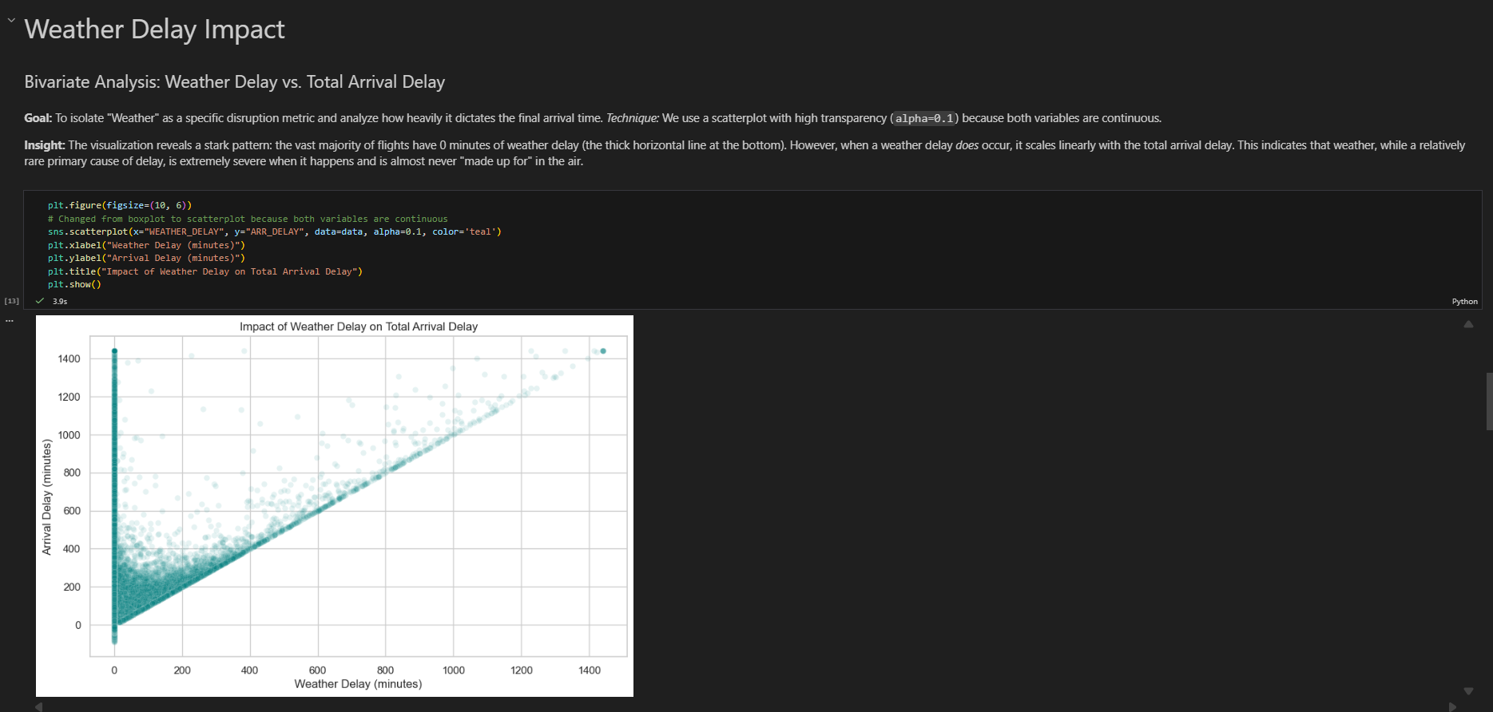
3. Categorical Analysis (Top 10 Airlines)
Goal: To compare the delay distributions among the highest-volume carriers.
Insight: Evaluating the Top 10 airlines reveals which carriers maintain tight operational variance (compact boxes) versus those prone to wider, less predictable delays.
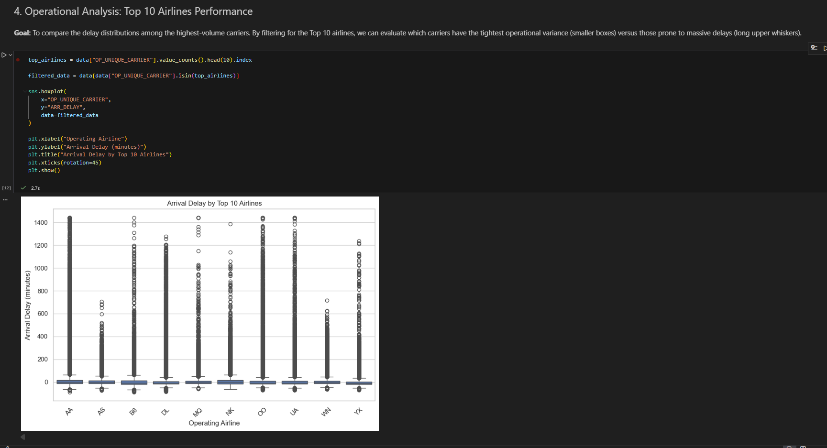
4. Feature Engineering & Seasonal Risk Factor
Goal: To transition from granular data (months) to macro-level operational trends (seasons) to assess passenger risk.
Insight: Rather than measuring average delay minutes, we defined a delay as >15 minutes (industry standard) to calculate the probability of a disrupted itinerary. This visualization proves that the time of year is a critical predictor of flight risk.
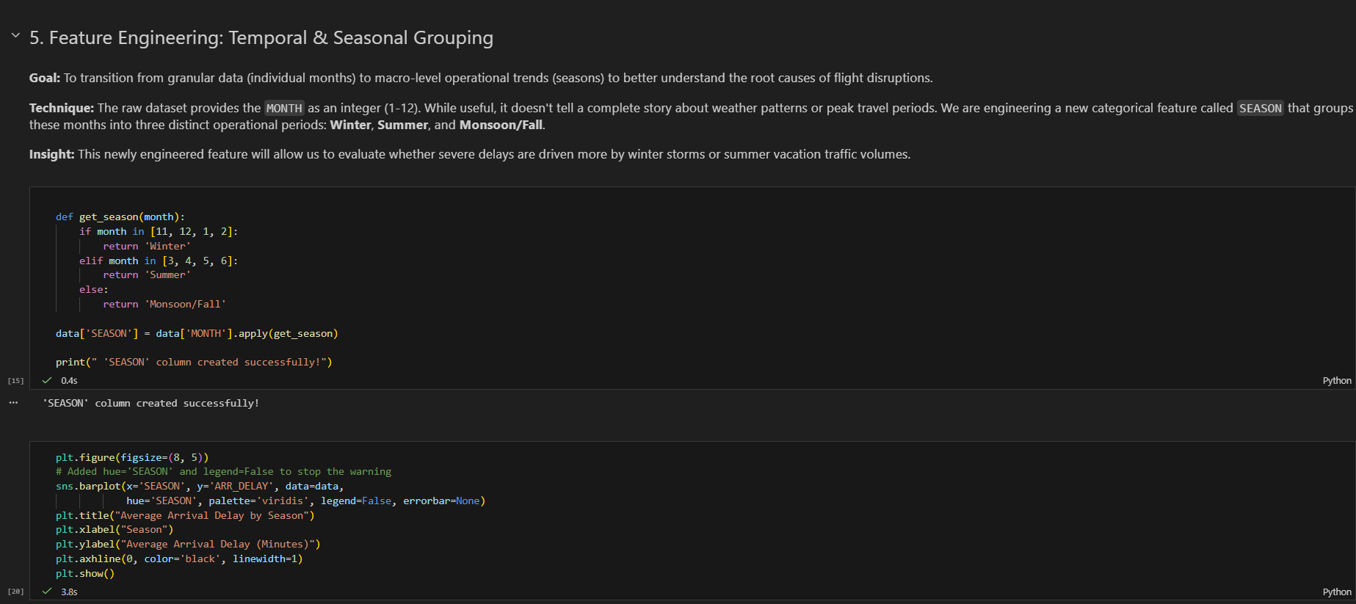

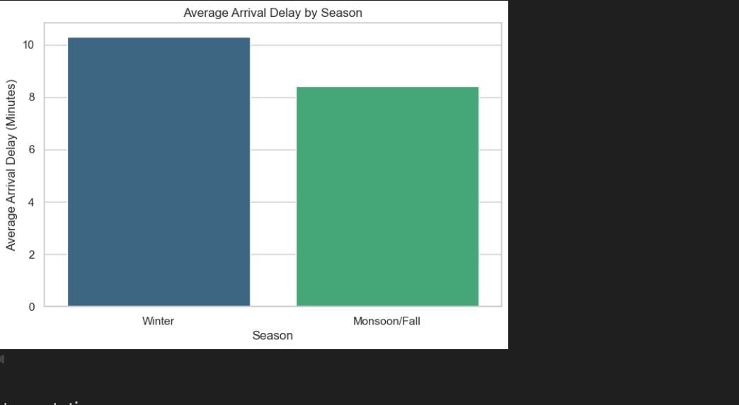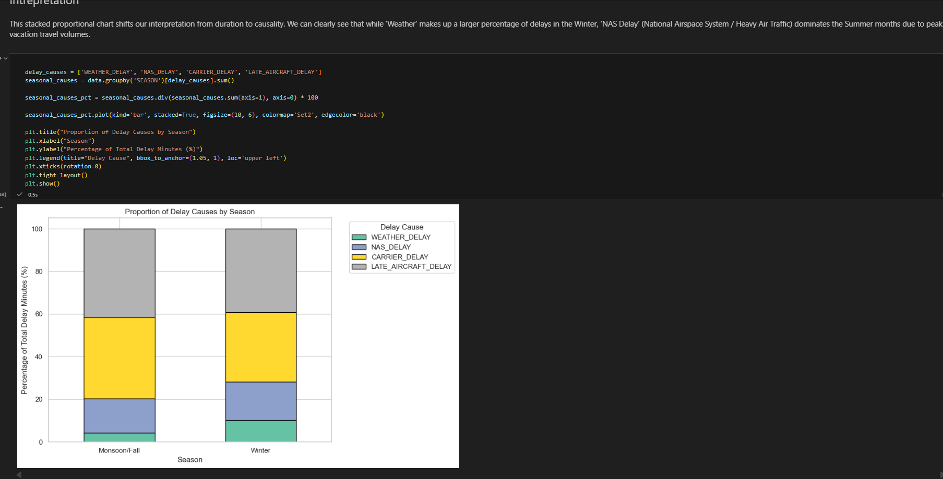
5. Correlation Matrix (Delay Causes)
Goal: To identify mathematical relationships between specific types of delays.
Insight: Strong positive correlations (approaching 1.0) indicate variables that move together. For example, DEP_DELAY and ARR_DELAY show near-perfect correlation, while individual causes like WEATHER_DELAY act entirely independently.
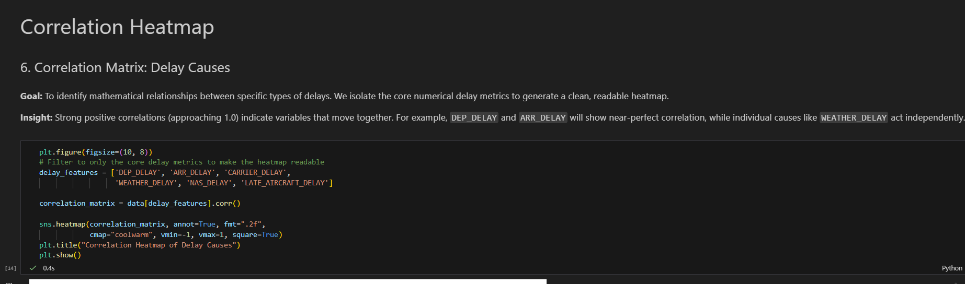
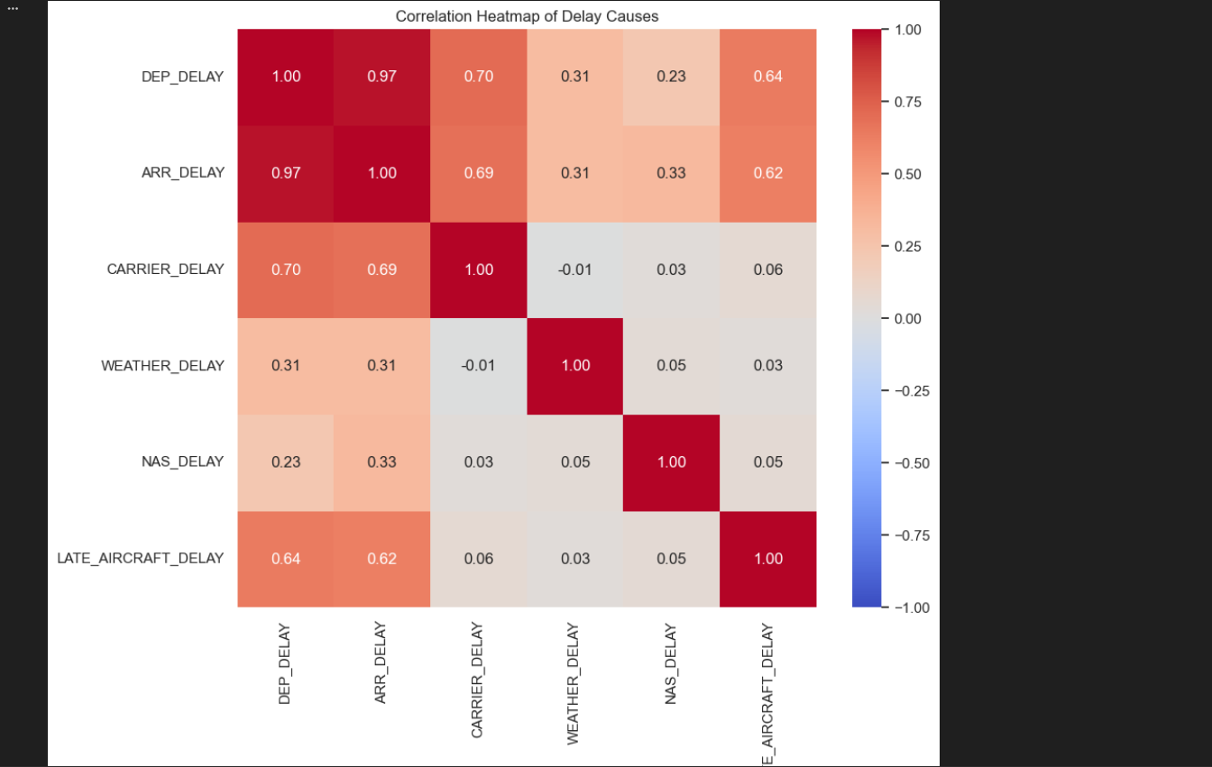

Week 4 Observations & Conclusion
- The Reality of Overplotting: We successfully adapted standard visualization techniques (using alpha blending and customized axis limits) to handle the reality of a 1.7-million-row dataset without losing visual integrity.
- The Departure-Arrival Link: Our density mapping proved that a delayed departure is the strongest predictor of a delayed arrival, though recovery in the air is frequently achieved.
- Seasonal Predictability: Feature engineering the SEASON column allowed us to shift our analysis from "how late" to "how likely," providing a highly valuable risk-assessment metric.
- Independence of Causes: The correlation heatmap confirmed that delay causes (Weather, Carrier, NAS) do not generally trigger one another; they act as independent bottlenecks in the aviation network.

Team Contribution
Team Member Name | Working | Outcome
24BAD067  Manoj M | Conducted Univariate Analysis and tuned histogram bins/axes to properly display heavy-tailed Big Data distributions. | Accurately visualized delay spreads without losing the curve to extreme outliers.
24BAD078  Neha N K | Developed Bivariate scatter plots, employing alpha-blending to solve overplotting issues for 1.7M rows. | Mapped the direct density correlation between departure and arrival delays.
24BAD055  Karthick N | Engineered the SEASON feature and developed the advanced Probability/Risk Factor visualization. | Extracted high-level business insights regarding seasonal disruption risks.
24BAD089  Pranesh M | Generated the categorical Top 10 Airline comparisons and the filtered Correlation Heatmap. | Identified operational variance across carriers and isolated independent delay triggers.

REFERENCES:
- Seaborn Documentation (Visualizing Distributions): https://seaborn.pydata.org/tutorial/distributions.html
- Matplotlib Documentation (Alpha Blending & Scatter): https://matplotlib.org/stable/api/_as_gen/matplotlib.pyplot.scatter.html
- Pandas Dataframe Groupby & Aggregation: https://pandas.pydata.org/pandas-docs/stable/reference/api/pandas.DataFrame.groupby.html

